Name:

ID:

VE230 Quiz 1  *10/13/2017*

*Hint: All the situations described in this quiz are in free space.*

1. (6pts) A conducting circular disk has a uniform positive surface charge density. Which of the following diagrams best represents the electric field lines from the disk? (The disk is drawn as a cross–section.)



1. 1
2. 2
3. 3
4. 4
5. None of the diagrams.

C

1. (4pts) An infinite plane lies in the $yz$ plane and it has a uniform surface charge density. The electric field at a distance *x* from the plane
2. Decreases linearly with *x*.
3. Decreases as 1/*x*2.
4. Is constant and does not depend on *x*.
5. Increases linearly with *x*.
6. Is undetermined.

C

1. (8pts) The electric field ***E*** in Gauss’s Law is
2. Only that part of the electric field due to the charges inside the surface.
3. Only that part of the electric field due to the charges outside the surface.
4. The total electric field due to all the charges both inside and outside the surface.

C

1. (4pts) A rod of infinite length has a charge per unit length of $l (= q/l)$. Gauss's Law makes it easy to determine that the electric field strength at a perpendicular distance *r* from the rod is, in terms of *k* = (4πε0)–1,



D

1. (4pts) An infinite plane of surface charge density $σ$ $= +8.00 nC/m^{2}$ lies in the $yz-$ plane at the origin, and a second infinite plane of surface charge density $σ$ $= –8.00 nC/m^{2}$ lies in a plane parallel to the $yz-plane$ at $x =4.00 m$. The electric field magnitude at $x = 5.00 m$ is approximately
2. 2x113 N/C
3. 3x113 N/C
4. 8x113 N/C
5. 4x113 N/C
6. zero

E

1. (8pts) A thin conducting plane with surface charge density $σ$ is exposed to an external electric *E*ext. The difference in the electric field between one surface of the plane to the other surface is



1. /ε0
2. /ε0 + *E*ext
3. /ε0 − *E*ext
4. 2 /ε0 + *E*ext
5. /2ε0 + *E*ext

A

1. (8pts) The electric field at the surface of a conductor
2. Is parallel to the surface.
3. Depends only on the total charge on the conductor.
4. Depends only on the area of the conductor.
5. Depends only on the curvature of the surface.
6. Depends on the area and curvature of the conductor and on its total charge.

E

1. (4pts) Three point charges lie at the vertices of an equilateral triangle as shown. Charges #2 and #3 make up an electric dipole. The net electric *torque* that Charge #1 exerts on the dipole is,



A. Clockwise.

B. Counterclockwise.

C. Zero.

D. Not enough information given to decide

A

1. (6pts) A small sphere hangs by an insulating thread within a larger, hollow conducting sphere. A conducting wire extends from the small sphere through, but not touching, a small hole in the hollow sphere. A charged rod is used to transfer positive charge to the wire. After the charged rod has touched the wire and then removed, are the following surfaces, positive, negative or not charged?

The small sphere:

The inner surface of the hollow sphere:

The outer surface of the hollow sphere:

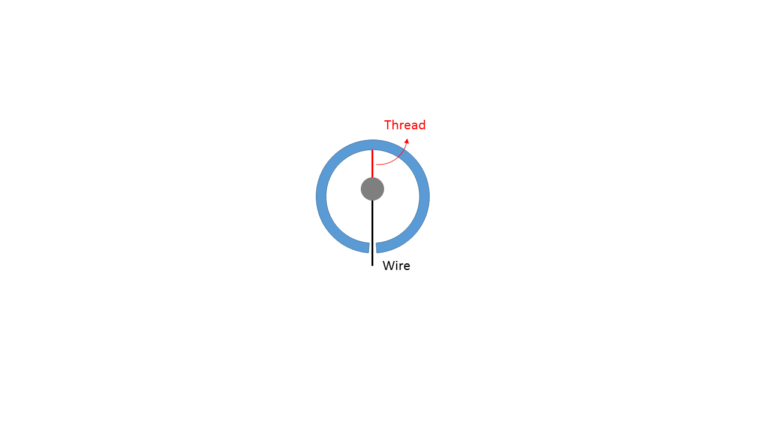

Positive

Negative

Positive

1. (8pts) Suppose $∇×E=2\hat{k }\frac{V}{m^{2}}$ everywhere. Provide an expression for the circulation $\oint{E∙dl}$ for the closed loop with radius 1m in the clockwise direction shown as below.

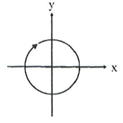

1. Zero
2. $2π$ V
3. $4π$ V
4. $1π$ V
5. None of above

E

1. (6pts) A point charge +Q is outside a hollow spherical conducting shell.

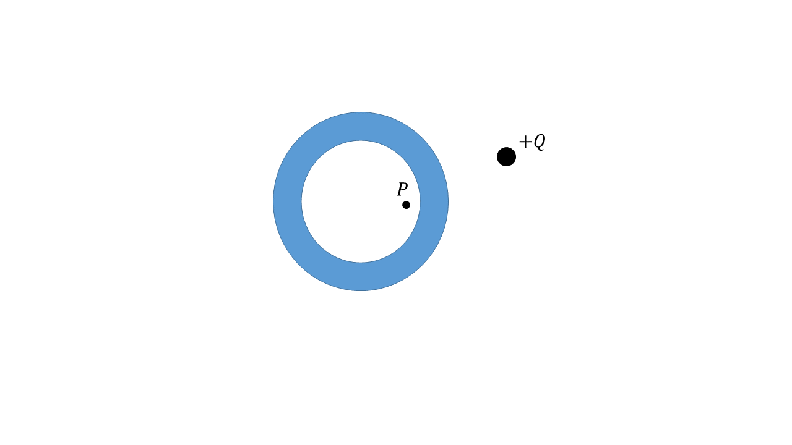

The electric field at point P inside of the shell

1. Zero
2. Directed to the right
3. Directed to the left

A, Faraday cage

1. (8pts) A hollow spherical conducting shell has no charge. A charge $+q$ is in the hole, shifted from the center as shown. What does the electric field look like in the “hole” region?

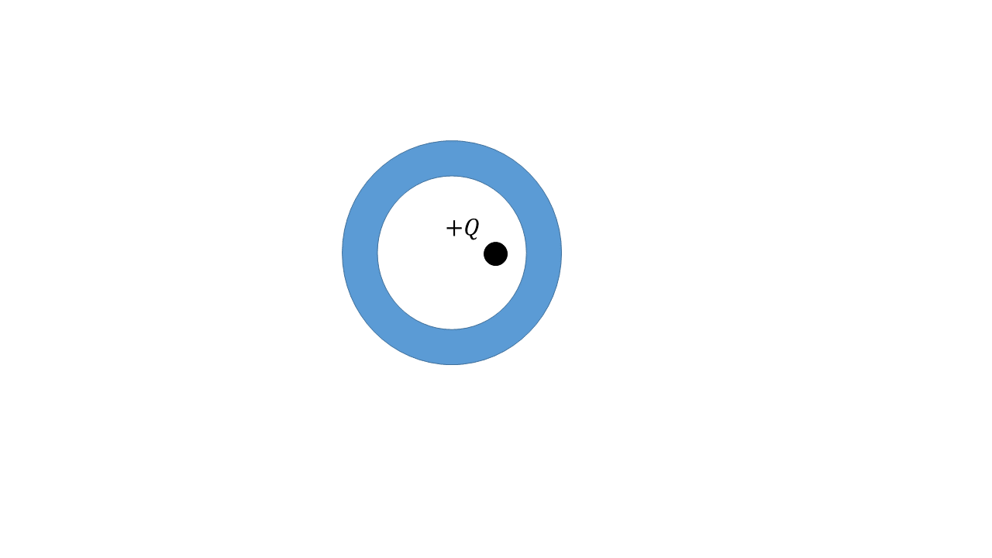

1. Simple coulomb field straight away from +q, right up to the wall
2. Complicated as it is hard to compute

B

1. (6pts) Are there any locations, a finite distance from the charges, on the straight line passing through point A and the negative charge at which the net electric field due to the charges equals zero? If so where is the field zero?

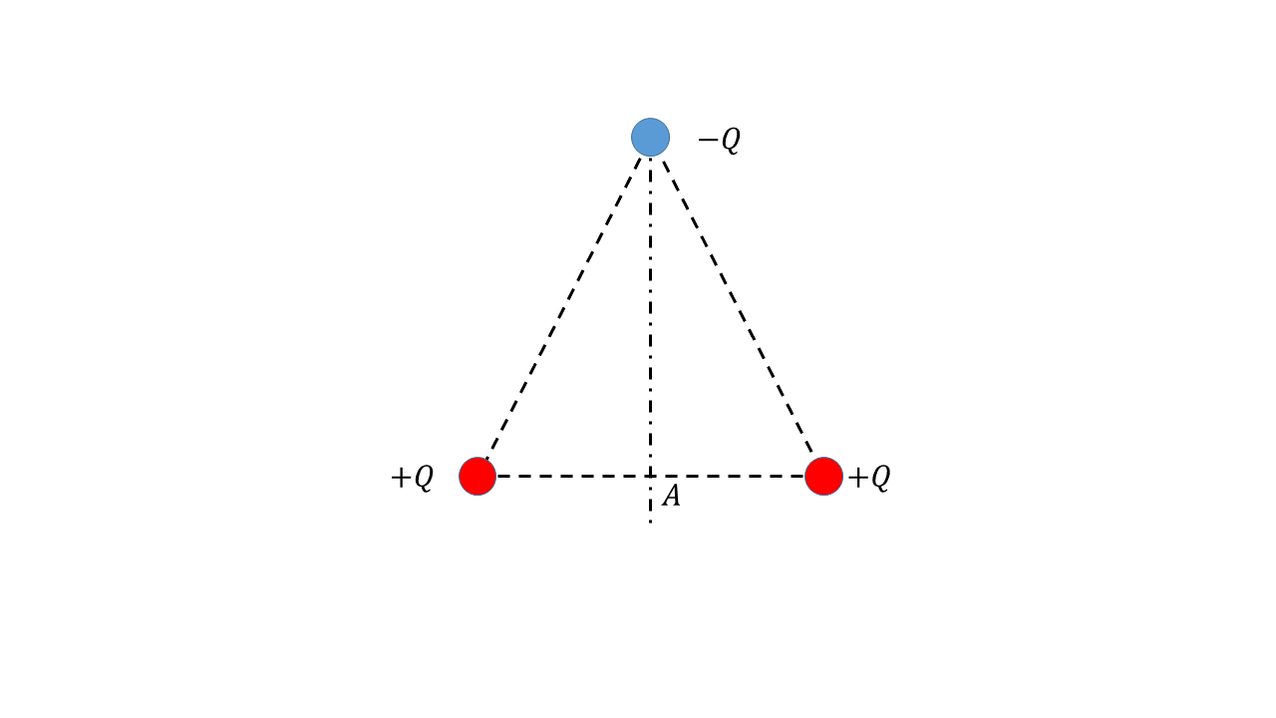

1. At some point above the negative charge
2. At some point between the negative charge and point A
3. At some point below A
4. Both A and C
5. Both B and C
6. None of the above

D

1. (10pts) A charged balloon expands as it is blown up, increasing in size from the initial to final diameters shown. Do the electric fields at point 1,2 and 3 increase, decrease, or stay the same? Explain your reasoning for each case.

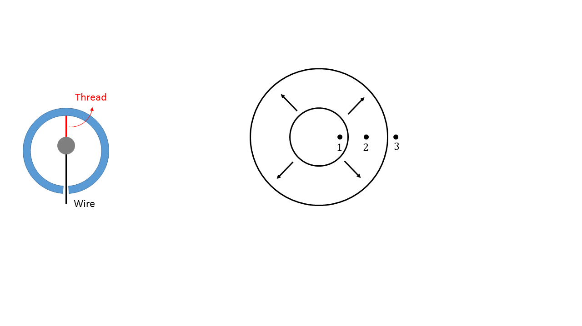

See file “Expanding charged balloon” for solution

1. (10pts) The figures shown below are cross sections of three-dimensional closed surfaces. They have a flat top and bottom surface above and below the plane of the page, but there is no flux through the top or bottom surface. The electric field is **uniform over each face of the surface**. The field strength, in $N/C$, is shown. Each surface contains no net charge. Draw the missing electric field vector (or write $\vec{E}=\vec{0}$) in the proper direction. Write the field strength beside it.

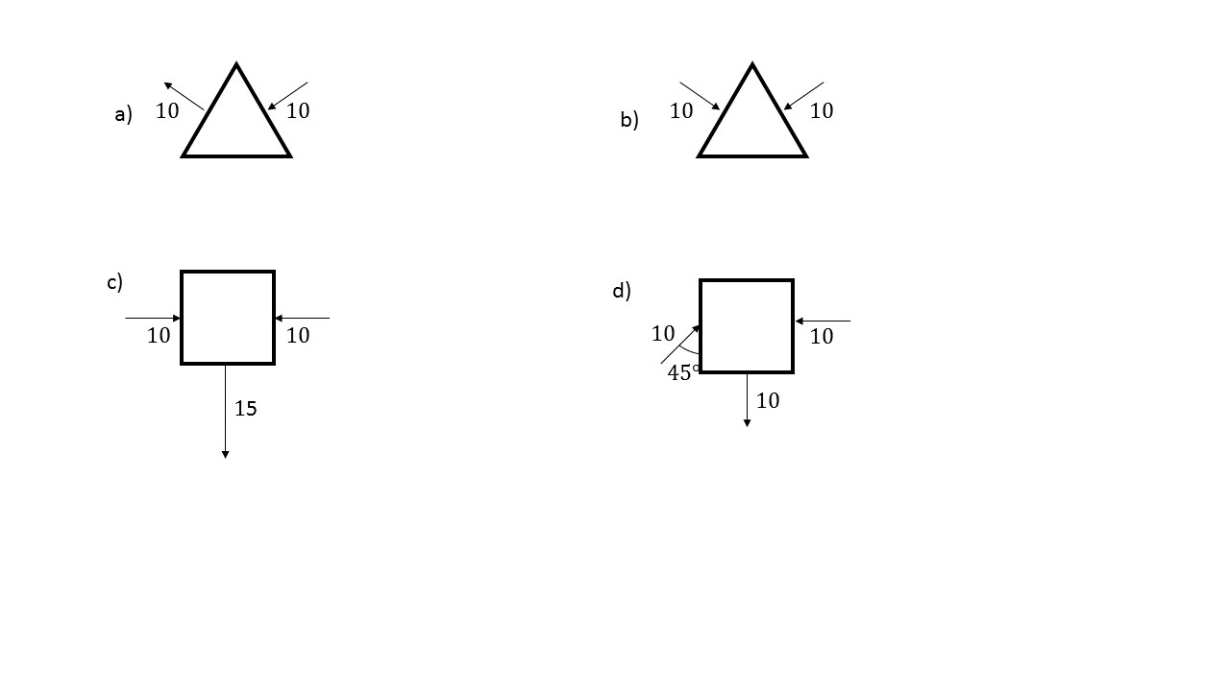

a) $\vec{E}=\vec{0}$

b) Field strength = 20, exiting

c) Field strength = 5, exiting

d) Field strength = 7.07, exiting